**Experiment-9**

**Aim: Study of PL/SQL and comparison with MySQL**

The PL/SQL stands for **Procedural Language extensions to Structured Query Language**. Basically, SQL is used to perform basic operations of creating a database, storing data in the database, updating data in the database, retrieving the stored data of database, etc, whereas PL/SQL is a fully Structured **Procedural** language which enables the developer to combine the powers of SQL with its procedural statements.

## **Features of PL/SQL**

1. **Portable:**

PL/SQL applications can be executed with all types of operating system where we have oracle installed.

1. **Efficient:**

All sorts of calculations can be efficiently performed by PL/SQL without the use of oracle engine. This improves transaction performance.

1. **Error-checking:**

PL/SQL allows error-checking and displays user-friendly messages when error occurs.

1. **Development tool:**

PL/SQL supports execution of SQL statements along with the functionality of variable declaration, conditional statements, looping and branching, procedures, functions and triggers.

1. **Exception Handling:**

PL/SQL code is capable of handling exceptions that can affect the flow of program, hence helps in making the code more reliable.

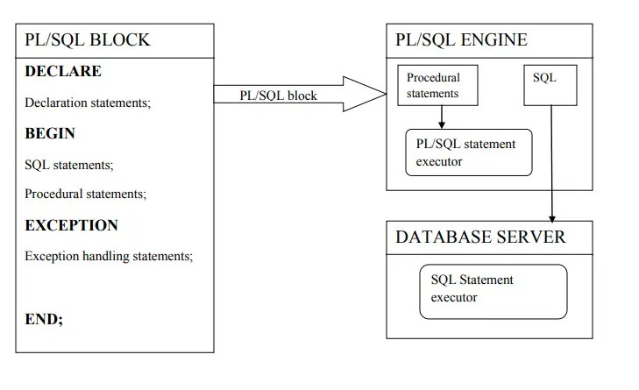**PL/SQL Architecture**

* **DECLARE Section:**

PL/SQL code starts with a declaration section in which memory variables and other oracle objects like cursor, triggers etc can be declared and if required can be initialized as well. Once declared/initialised we can use them in SQL statements for data manipulation. As it is not necessary that we would require variables etc in every PL/SQL code, hence this section is an optional section.

* **BEGIN Section:**

This section contains the SQL and PL/SQL statements that are required to be executed and contains the main logic. This section is responsible for handling the data retrieval and manipulation, may be working with branching, can use looping and conditional statements, etc.

* **EXCEPTION Section:**

This section is optional. It is mainly used to handle the errors that may occur between **BEGIN** and **EXCEPTION** sections.

* **END Section:**

This section is the indication of the end of the PL/SQL block.

**Difference between SQL and PL/SQL**

Following are the important differences between SQL and PL/SQL.

| **Sr. No.** | **Key** | **SQL** | **PL/SQL** |
| --- | --- | --- | --- |
| 1 | Definition | SQL, is Structural Query Language for database. | PL/SQL is a programming language using SQL for a database. |
| 2 | Variables | SQL has no variables. | PL/SQL has variables, data types etc. |
| 3 | Control Structures | SQL has no FOR loop, if control and similar structures. | PL/SQL has FOR loop, while loop, if controls and other similar structures. |
| 4 | Operations | SQL can execute a single operation at a time. | PL/SQL can perform multiple operation at a time. |
| 5 | Language Type | SQL is a declarative language. | PL/SQL is a procedural language. |
| 6 | Embedded | SQL can be embedded in a PL/SQL block. | PL/SQL can also be embedded in SQL code. |
| 6 | Interaction | SQL directly interacts with database server. | PL/SQL does not directly interacts with database server. |
| 7 | Orientation | SQL is data oriented language. | PL/SQL is application oriented language. |
| 8 | Objective | SQL is used to write queries, create and execute DDL and DML statments. | PL/SQL is used to write program blocks, functions, procedures, triggers and packages. |